DAV INSTITUTE OF ENGINEERING AND TECHNOLOGY
KABIR NAGAR, JALANDHAR
DEPARTMENTAL INFORMATION OF
CLASS REPRESENTATIVES AND CLASS INCHARGES OF
ELECTRONICS AND COMMUNICATION ENGINEERING

ECE-3rd SEMESTER , SECTION-A
(Session July-Dec. 2019)
Kritika Madaan
Roll NO. 37/18
78143-14213
E-mailid:Kritikamadaan70@gmail.com

37/18
CLASS REPRESENTATIVES
Bhavesh Aggarwal
Roll No.: 16/18
Mobile No.: 98772-01166
e-mail id: itsbhaveshhh@gmail.com
Mobile No.: 9877201166

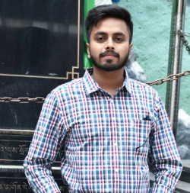
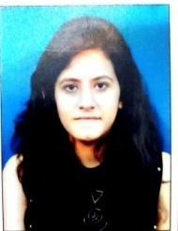

Dr. Ramnik Singh
e-mail id: 8.ramnik@gmail.com
Mobile No.: 94176-51066
CLASS INCHARGE

ECE-3rd SEMESTER , SECTION-B
(Session July-Dec. 2019)
Mr. Amit Arora
e-mail id: aroraamit.er@gmail.com
Mobile No.: 94637-28708

Roll No.: 202/18
e-mail id: 95lovish@gmail.com
Mobile No.: 95017-95380
CLASS REPRESENTATIVE
CLASS INCHARGE

q

Mr. Hari Singh  Assistant Prof. & Time-Table Incharge (ECE)  e-mail id: harisdhillon@gmail.com | Dr. Neeru Malhotra  Associate Prof. & Head (ECE)  e-mail id: ece@davietjal.org

DAV INSTITUTE OF ENGINEERING AND TECHNOLOGY
KABIR NAGAR, JALANDHAR

DAV INSTITUTE OF ENGINEERING AND TECHNOLOGY
KABIR NAGAR, JALANDHAR
DEPARTMENTAL INFORMATION OF
CLASS REPRESENTATIVES AND CLASS INCHARGES OF
ELECTRONICS AND COMMUNICATION ENGINEERING

ECE-5TH SEMESTER (Session July-Dec. 2019)
Mr. Rajesh Wadhwa
e-mail id: rajesh7847@rediffmail.com
Mobile No.: 94783-70735
CLASS INCHARGE

CLASS REPRESENTATIVES
Deepika Khokhar
Roll No.: 17/17
e-mail id: aladeep900@gmail.com
Mobile No.: 70095-55868
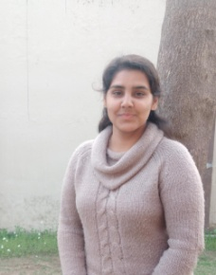

Mr. Hari Singh  Assistant Prof. & Time-Table Incharge (ECE)  e-mail id: harisdhillon@gmail.com | Dr. Neeru Malhotra  Associate Prof. & Head (ECE)  e-mail id: ece@davietjal.org

DAV INSTITUTE OF ENGINEERING AND TECHNOLOGY
KABIR NAGAR, JALANDHAR
DEPARTMENTAL INFORMATION OF
CLASS REPRESENTATIVES AND CLASS INCHARGES OF
ELECTRONICS AND COMMUNICATION ENGINEERING

ECE-7TH SEMESTER , SECTION-A
(Session July-Dec. 2019)
Himanshu Singh
Roll No.: 33/16
Mobile No.: 75088-77394
e-mail id:hkskv082@gmail.com
CLASS REPRESENTATIVES
Minni Pathak
Roll No.: 45/16
Mobile No.: 97790-94957
e-mail id:minipathak184@gmail.com

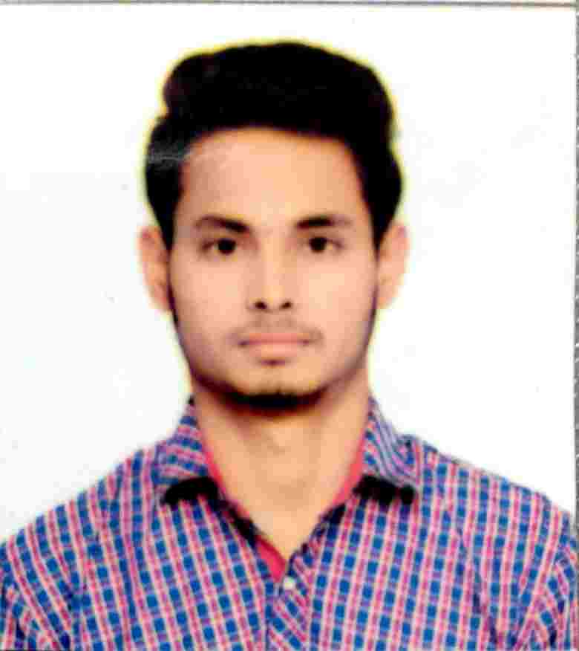
Mr. Navleen Singh Rekhi
e-mail id:navleenr@yahoo.com
Mobile No.: 98155-00850
CLASS INCHARGE

DAV INSTITUTE OF ENGINEERING AND TECHNOLOGY
KABIR NAGAR, JALANDHAR

Mr. Hari Singh  Assistant Prof. & Time-Table Incharge (ECE)  e-mail id: harisdhillon@gmail.com | Dr. Neeru Malhotra  Associate Prof. & Head (ECE)  e-mail id: ece@davietjal.org

ECE-7TH SEMESTER , SECTION-B
(Session July-Dec. 2019)

Shallu Thethi
Roll No.: 209/16
Mobile No.: 62807-33393
e-mail idthethishalu@gmail.com
CLASS REPRESENTATIVES
Pallvi Mahajan
Roll No.: 209/16
Mobile No.: 76966-17870
e-mail id:pallvimahajan1998@gmail.com
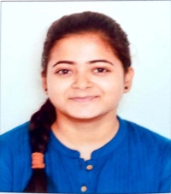
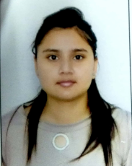

CLASS INCHARGE

Ms. Poonam Sethi
e-mail id: poonam257161@yahoo.com
Mobile No.: 98761-60704

DAV INSTITUTE OF ENGINEERING AND TECHNOLOGY
KABIR NAGAR, JALANDHAR
Mr. Hari Singh  Assistant Prof. & Time-Table Incharge (ECE)  e-mail id: harisdhillon@gmail.com | Dr. Neeru Malhotra  Associate Prof. & Head (ECE)  e-mail id: ece@davietjal.org

